DISTRICT 6980 DDF GRANT FOR DICTIONARIES
Rotary Club of Winter Park Winter Park, Florida
DISTRICT GRANT #2526-17
FINAL REPORT 2025-2026

TABLE OF CONTENTS

Cover page 1
Table of Contents page 2
Final Report with club authorized signatures pages 3 thru 10
Grant Approval 5-21-25 page 11
Final Report Club signature page 12
District DDF Tracking Form Appendix A page 13
District Grant Workshop 25-26 Attendance Appendix B page 14
District Grant Workshop 24-25 Attendance Appendix C page 15

FINAL REPORT
DG # 2526-17 Rotary Club of WINTER PARK
Project Title: The Killarney Elementary School Food Pantry Project
- Project Description---Briefly describe the project. What was done, when and where did project activities take place and who were the beneficiaries?

Maternal and Child Health is this project Area of Focus: The Winter Park Rotary Club has supported the Killarney Elementary School Food Pantry for more than 14 years. We discovered that some children going to school at Killarney were hungry, unable to learn. From that time, we have packed food for the homeless and hungry children for the weekends. According to the school principal and the school’s records, the children receiving food have improved their testing scores. We buy our food at Second Harvest Food Bank at the lowest prices possible. This grant money will buy food at Second Harvest.

The Winter Park Rotary Club has a dedicated committee that packs food for school administration identified homeless students/families each Wednesday morning at the Killarney Food Pantry. The number of homeless students and families has reached 100. Food is packed and distributed to the students each Wednesday that school is in session. This committee is led by Winter Park Rotarian Ann Clement.

- How many Rotarians participated in the project? 11 club members regularly participate in the packing of food and distribution to the students each Wednesday. The bags of packed food are left at the door of the classrooms for the students at the end of the school day.

Ann Clement* Karen Gourlay Fred Jones
Kathleen Peters PE 26-27 Jim Hardy Diana Didawi
Ali DeMaria P 25-26 Tom Sacha
Carla Rivera Jennifer Bloodworth Michael Sidawi

*Ann Clement Chairs this project.

- What did they do? Please give examples and submit photos.

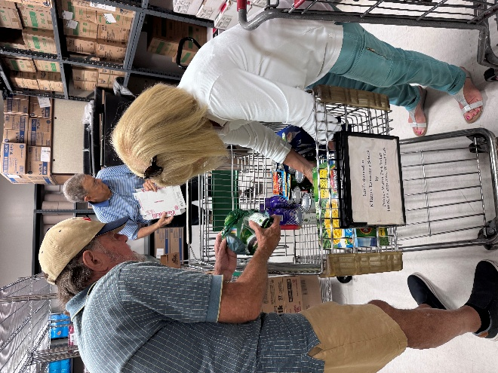
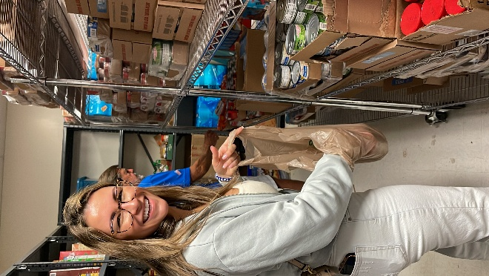

Restocking food pantry shelves
Diana Sidawi packing food bags

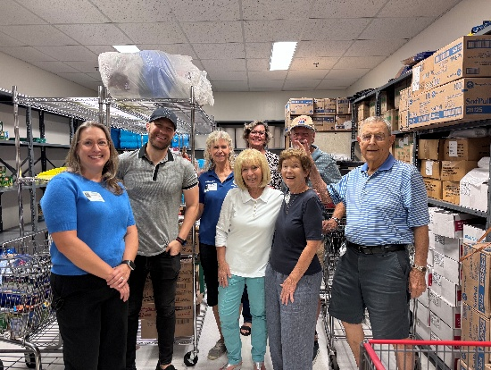
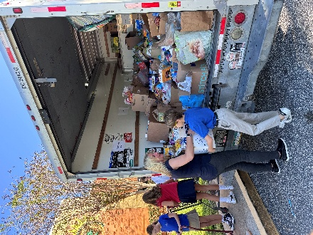

Replacing inventory from
Second Harvest Food Bank
Teamwork!

- How many non-Rotarians benefited from the project? 100 families

This current school year 100 Killarney Elementary school students and their families are benefiting from the Killarney Food Pantry each week of the school year.

- What benefit does the community have from this project?

100 Killarney student families of the homeless classified community are benefitting from food provided thru the Killarney Food Pantry coordinated by the Rotary Club of Winter Park and funded by the Rotary Club of Winter Park, other monetary donations, and food donations.

- If a cooperating organization was involved, what was its role?
NA
- Financial Report – Must supply receipts of all expenditures.

  - Income __ Amount
District Grant funds__________________ $410.00
Other funding__OCPS Foundation funds___ $1152.82
Total funding___________________ $1562.82

  - Expenditures Amount
_____Various food items_ $1562.82
Total Project Expenditures ______ $1562.82

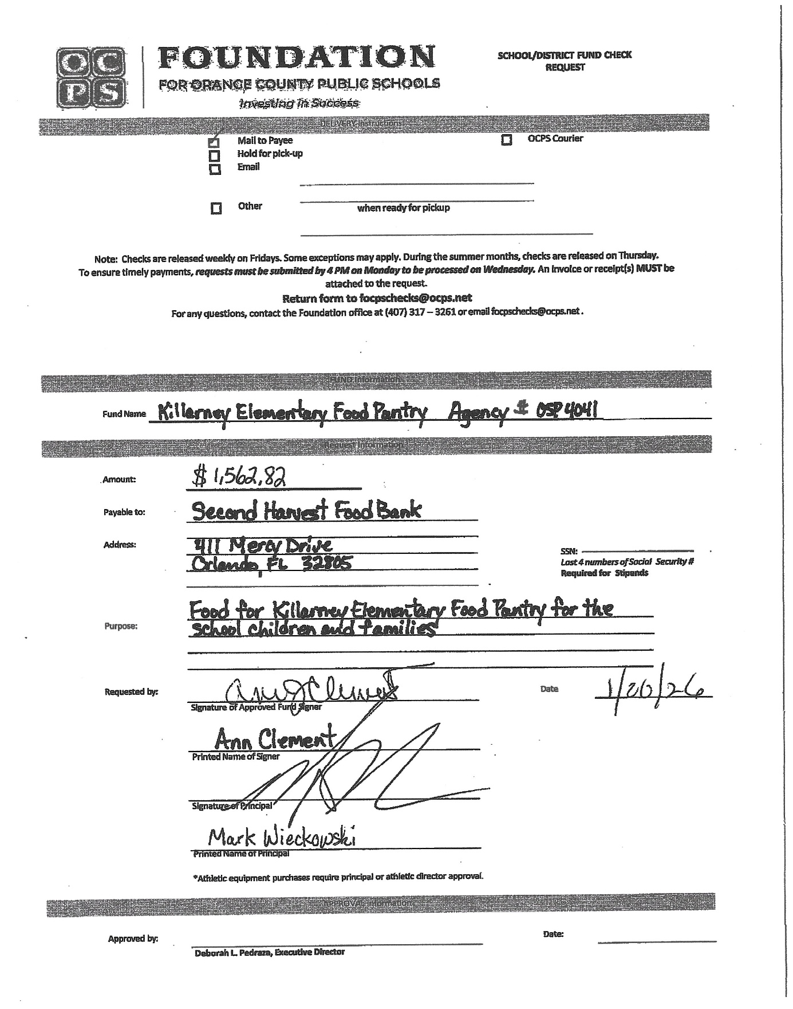
OCPS Foundation Check Request
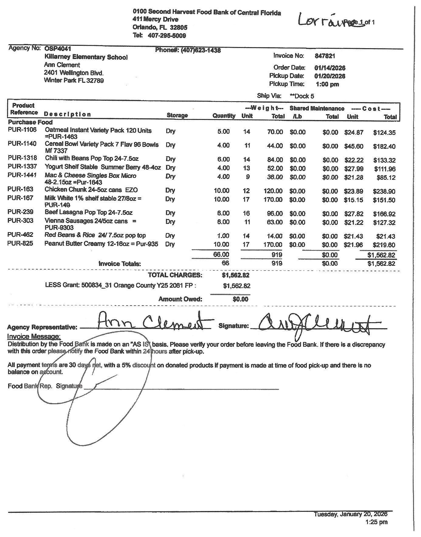
Food Items Purchased



ROTARY DISTRICT 6980 DISTRICT GRANT APPROVAL 2025-2026
To be completed by the District Grant Subcommittee Chair
TO: Rotary Club of Winter Park
Your request for funding of a District Grant has been approved by the District Grant Committee.
The amount of DDF approved is $410
Your District Grant # is DG2526-17
This Grant Number should be used on all communications. You can proceed with your District Grant beginning July 1. You must adhere to the rules and procedures outlined by the District Grant Committee. Please complete and submit the attached Final Report provided to the District Grants Subcommittee District6980Grants@yahoo.com by 30 April 2026. If the complete/signed final report is not received by April 30, 2026, your District Grant will be invalidated and no DDF funds will be reimbursed.
The Final Report must include:
● Clearly labeled receipts and for all items purchased.
● An account of Rotarian participation in the grant implementation
● A narrative that includes information about the project completion
● A detailed and clearly organized report of all expenses with copy of cancelled checks
● Photos of the completed project District
Grants are DDF reimbursement grants. Only upon receipt and successful processing of your grant’s final report will your Rotary Club be reimbursed for the approved amount.
District Rotary Foundation Chair Application Approvals
Application Approval Date: Click or tap to enter a date.
Final Report Approval Date: Click or tap to enter a date.
Check # _________for $ ________ Date: ________________ Rotary Year 2025-2026
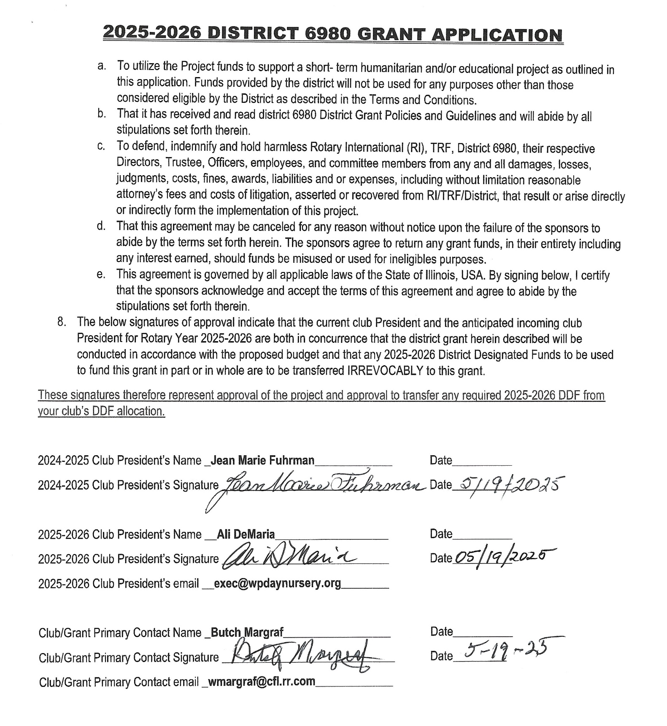
DISTRICT 6980 GRANTS FINAL REPORT Signature
Appendix A
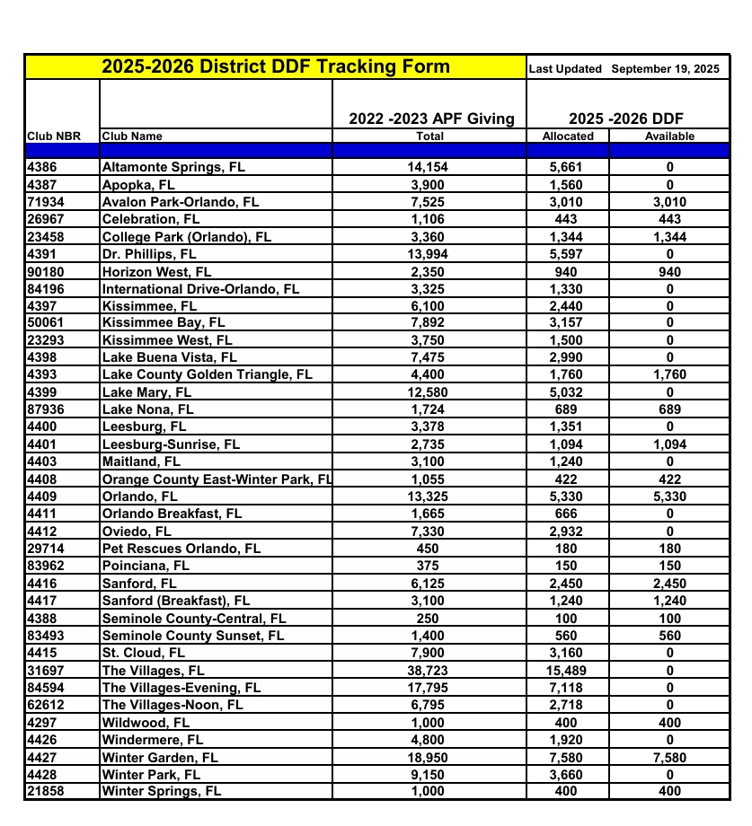

Appendix B
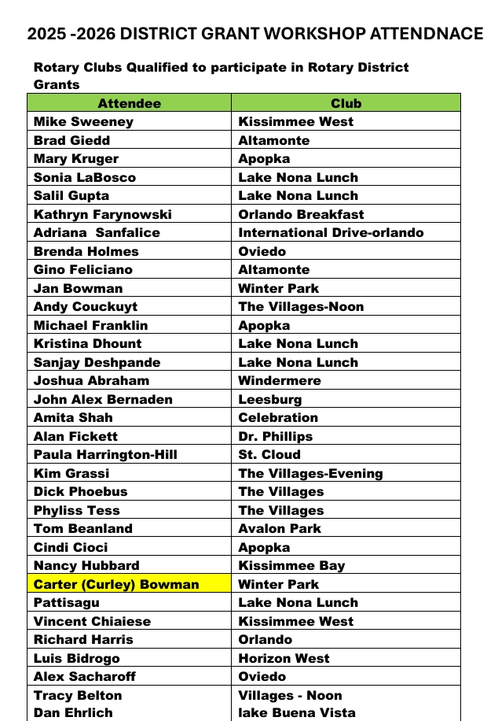
Wayne Margraf Winter Park
Kathleen Peters Winter Park
Curley Bowman Did not attend
Attendance C